**sed:**

**Q. Write a sed command that prints lines numbers of lines beginning with “O”.**



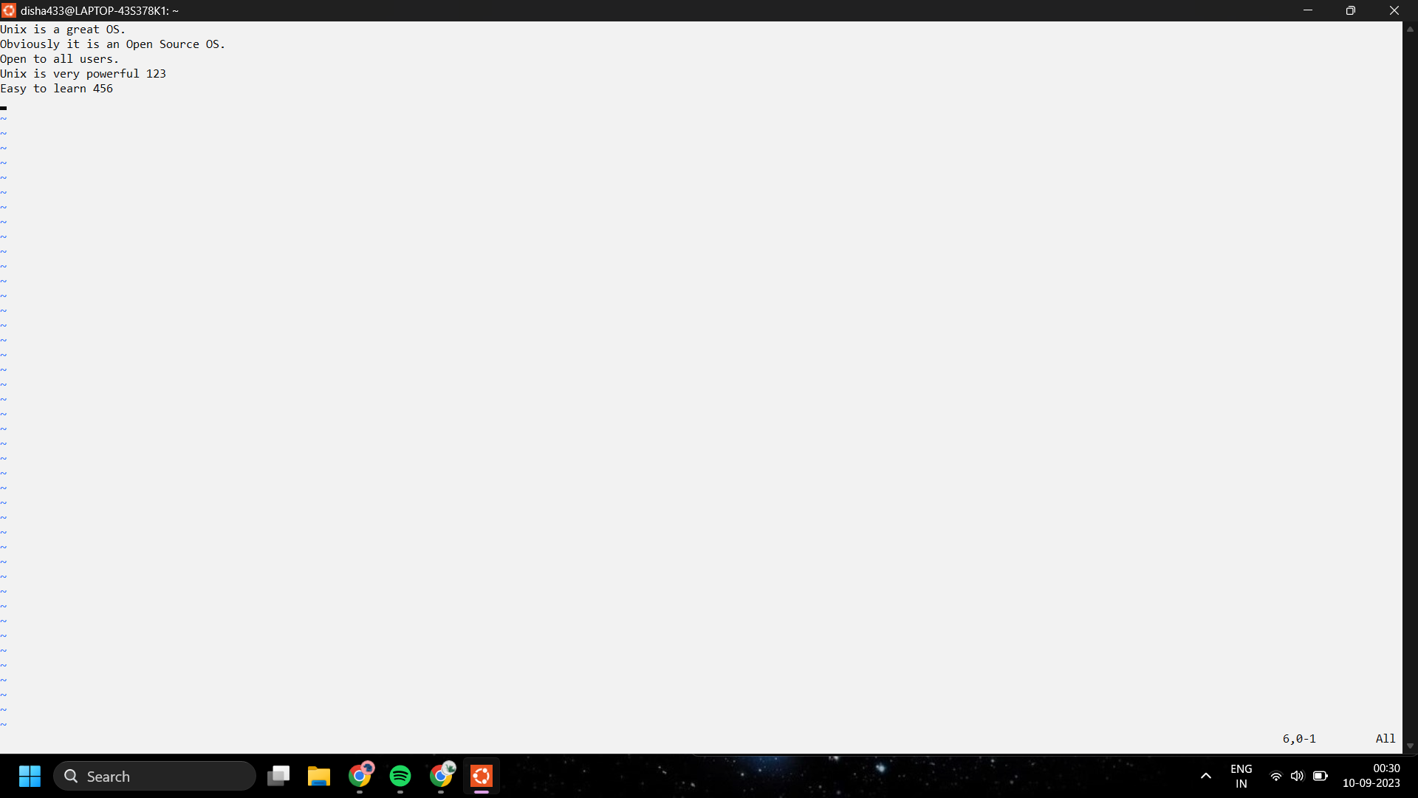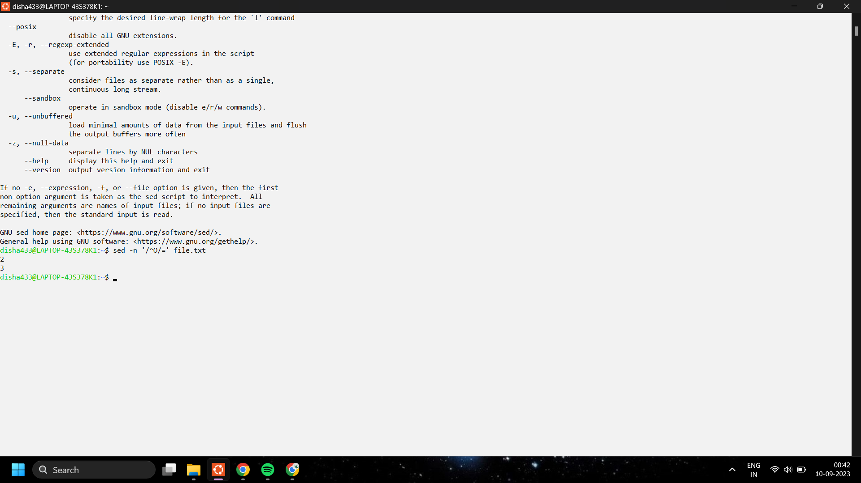

**Q. Write a sed command that deletes digits in the given input file.**

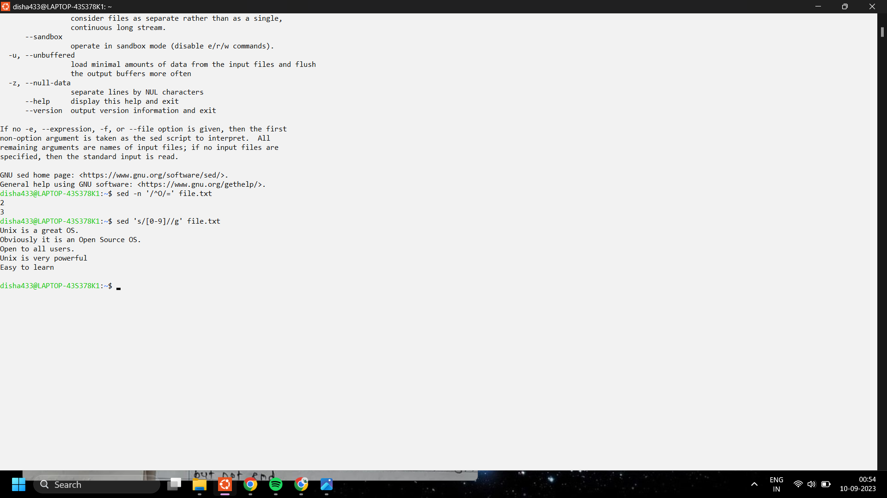

**Q. Write a sed command that deletes lines that contain both BEGIN and END.**

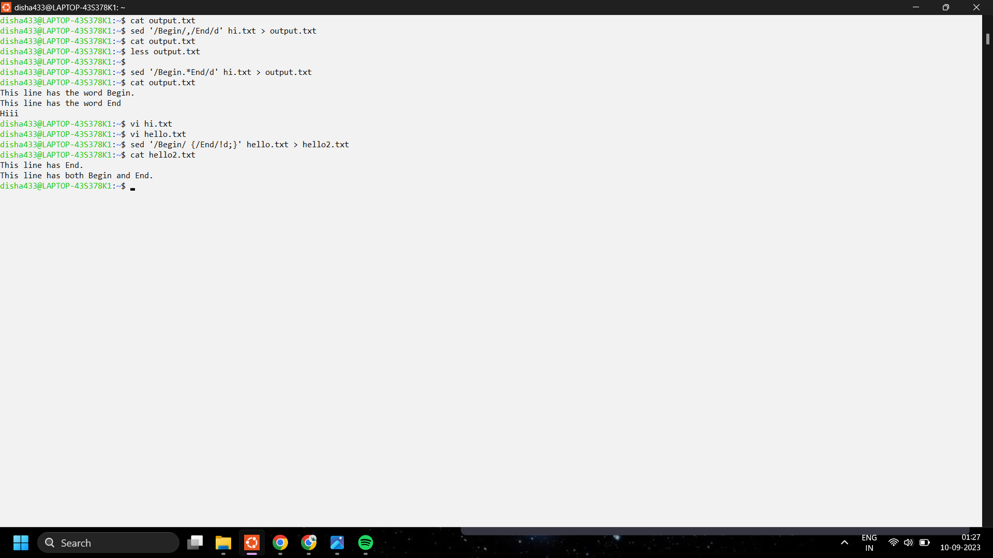

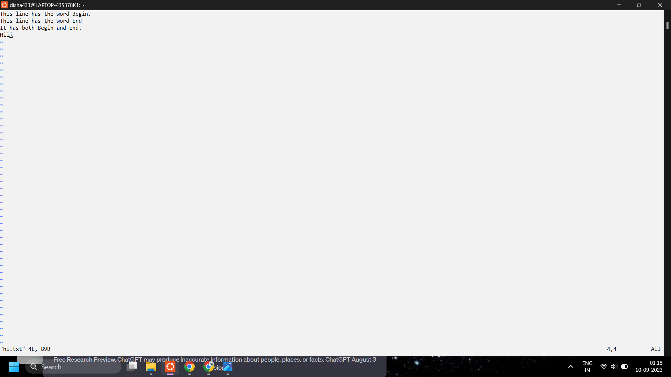

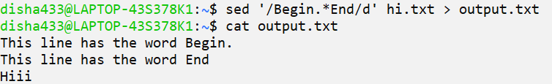

**Q. Write a sed command that deletes lines that contain BEGIN but not END.**

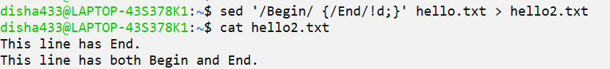

**Q. Write a sed command that deletes the first character in each line in a file.**

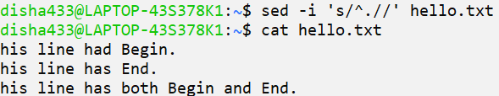

**Q. Write a sed command that deletes the last character in each line in a file.**

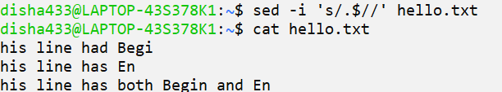

**awk:**

**Q. Write an awk command to print the lines and line number in the given input file.**

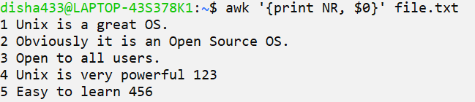

**Q. Write an awk command to print first field and second field only if the third field value is >=50 in the given input file. (input field separator is “:” and output field separator is “,”)**



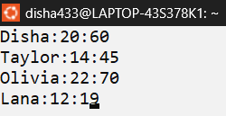



**Q. Consider the marks.txt is a file that contains one record per line (comma separate fields) of the student data in the form of studentid, student name, Telugu marks, English marks, Maths Marks, Science marks, Social Marks. Write an awk script to generate results for every student in the form of studentid, studentname, TotalMarks and result. Result is PASS if marks is >=30 in TELUGU and English, and if marks>=40 in other subjects. Result is FAIL otherwise.**



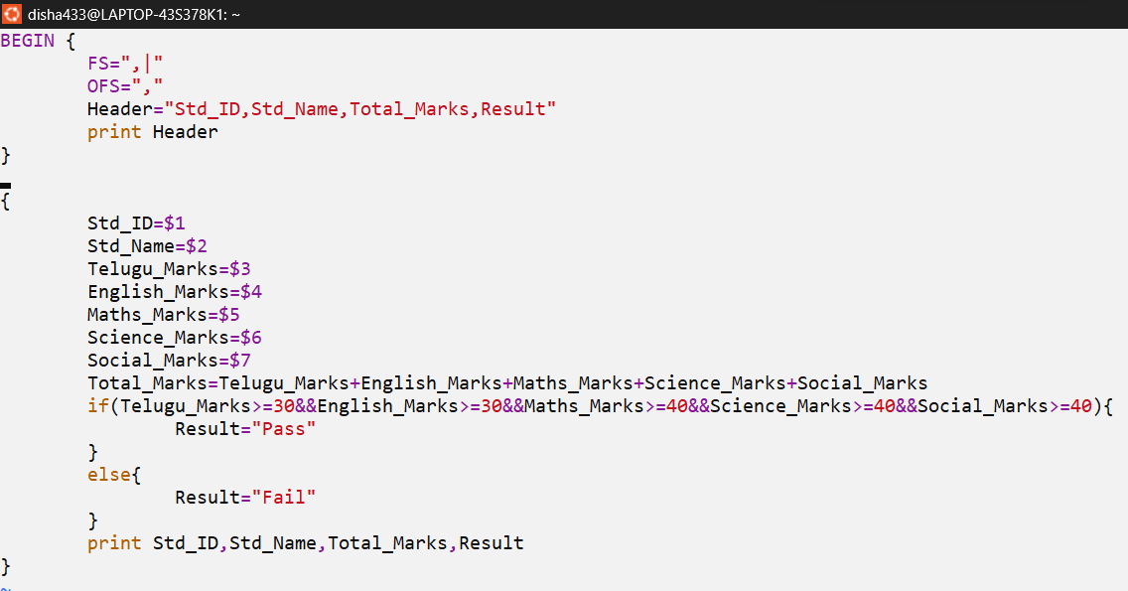



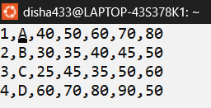

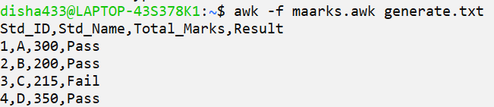

**grep:**

**Consider the below file as an input.**

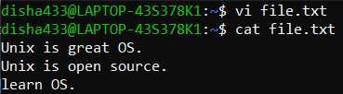

**1. Case insensitive search :**



**2. Displaying the count of number of matches :**



**3.Display the file names that matches the pattern :**

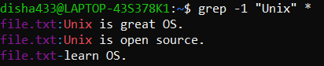

**4. Checking for the whole words in a file :**



**5. Displaying only the matched pattern :**



**6. Show line number while displaying the output using grep -n :**



**7. Inverting the pattern match : **

**8. Matching the lines that start with a string :**



**9. Matching the lines that end with a string :**



**10.Specifies expression with -e option. Can use multiple times :**

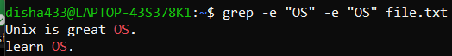

**11. -f file option Takes patterns from file, one per line.**



